**Task No.01:** **Write step how to install visual studio.**

**Solution:**

**Step 01:** Go to: <https://visualstudio.microsoft.com/vs/community/>

**Step 02:** Click on the download button.

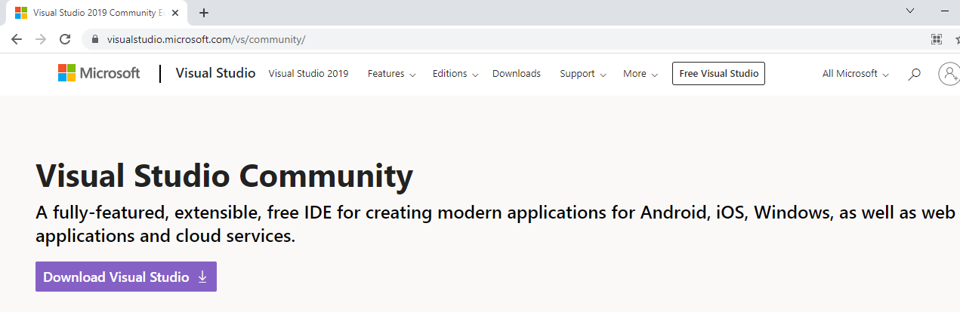

**Step 03: Then start the application.**

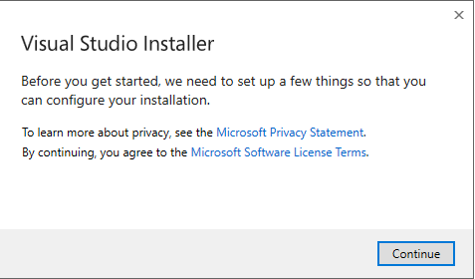

**Step 04:** Click continue. The visual studio installer will start.

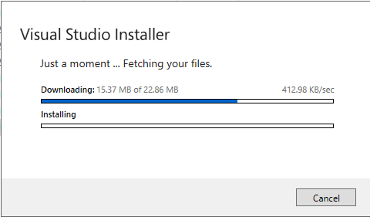

**Step 05:** After the installation is completed you will get the options to select the type of workloads you want to install in your visual studio. Select the options you want and then click on install.

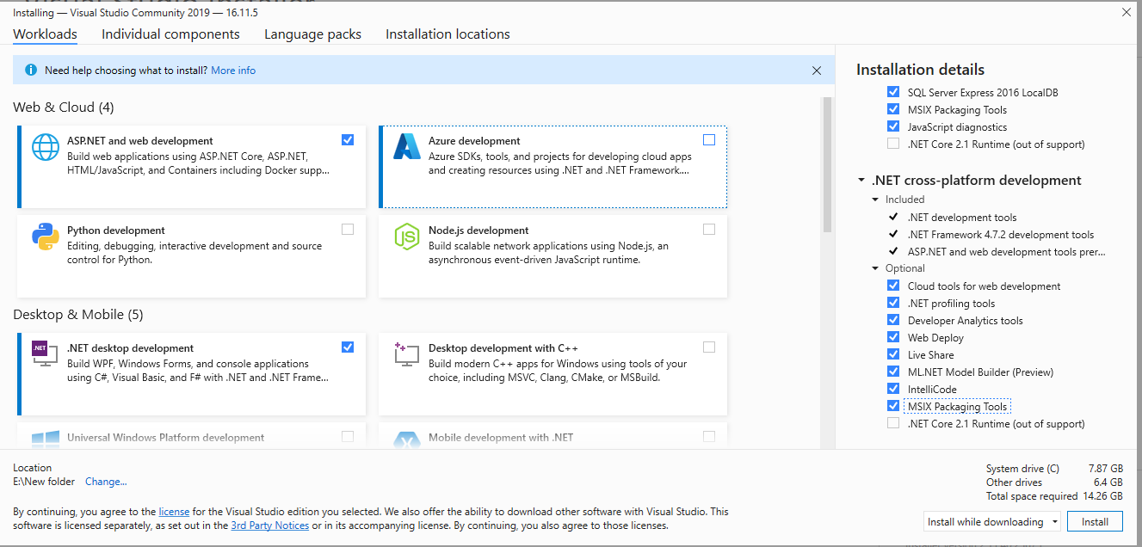

**Step 06:** Then visual studio installer will start.

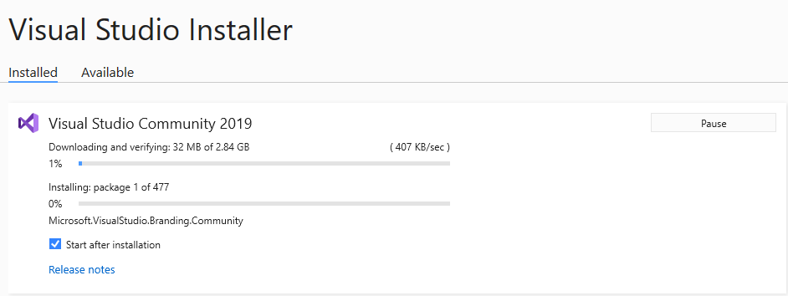

**Step 07:** After the installation is successfully completed the visual studio will start and you can start programming.

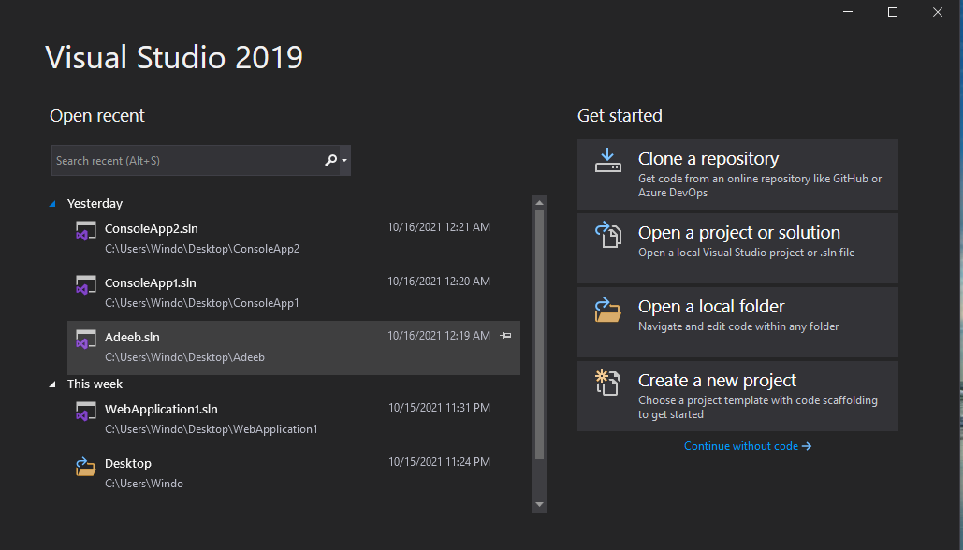

**Task No. 02: BASICS**

**Solution:**

using System;

namespace programminglab_01

{

classProgram

{

staticvoid Main(string[] args)

{

//Console.WriteLine("Hello World!");

Console.Write("I am \"software engineer\" \n");

Console.WriteLine("\t \tCP LAB");

Console.Write("I am an engineer");

}

}

}

**Output:**

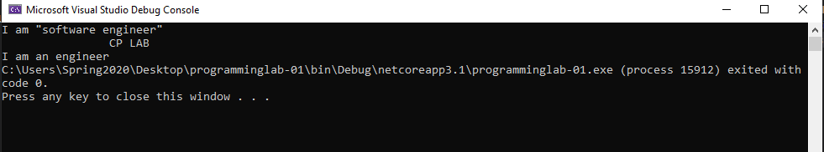

**Task No 03:** PROFILE DESSIGNING.

**Solution:**

using System;

namespace adeeb

{

Class Program

{

staticvoid Main(string[] args)

{

Console.WriteLine("------MY PROFILE------");

Console.WriteLine("Name: \"ADEEB UL HASSAN\" ");

Console.Write("Age: 17");

Console.WriteLine("\nEmail: \"adeeb123473@gmail.com \" ");

Console.WriteLine("Program: BSE");

Console.Write("Hobby: FOOTBALL");

Console.WriteLine("\nDate Of Birth: 12-04-2003");

}

}

}

Output:

